Report
Of
Practical Training
(CSE- 402-F)

Submitted in partial fulfillment of the
Requirements (of CSE-8th Semester) for the award of

BACHELOR OF TECHNOLOGY
IN
COMPUTER SCIENCE AND ENGINEERING

Duration of Training :- ( Jan – June , 2019)

Submitted to : Submitted by:
Sunil Makkar Name: Krishan Kumar
Assistant Professor (CSE) Class : CSE-8th Sem
Roll No : 15-CSE-2816

BRCM COLLEGE OF ENGINEERING AND TECHNOLOGY , BAHAL
BHIWANI (HARYANA)

Table of Contents

Description

1.0 Introduction
1.1 Purpose
1.2 Scope
1.3 Definition, Acronyms, and Abbreviations
1.4 References
1.5 Technologies to be used

2.0 Overall Description

2.1 Software Interface
2.2 Product Function
2.3 User Characteristics
2.4 Usage method
2.5 Assumptions and Dependencies

3.0 Specific Requirements
3.1 Use Case Reports
3.2 Supplementary Requirements

Software Requirements Specification

1.0 Introduction:
There are multiple softwares tought in schools and colleges. It requires constant installation of different software with requirements time to time. Installing them almost every week or month on hundreds of computers is too tiring and time consuming job. This software is developed to overcome this problem

1.1 Purpose:

This Software is created keeping in mind the difficulties of lab assistants while installing one software over multiple devices individually.
With the help of LabAssistant one software can be installed on multiple devices simultaneously and remotely.
It requires One time setup.
One Device should act as server and others as client.
Server should have this software installed.
1.2 Scope:

The scope of the Lab Assistant includes :

Schools
Colleges
other Private owned computer labs

1.3 Definitions, Acronyms, and Abbreviations:
• J2EE (Java 2 Enterprise Edition): It is a programming platform, belonging to the Java platform, which is used for developing and running distributed java applications.

  - References:

The following websites are referred :
http://www.w3schools.com/
http://www.javatpoint.com/
http://www.tutorialspoint.com/

1.5 Technologies to be used:

J2EE: (Servlet, JSP) Application architecture.

JAVA: Application architecture.

RegShot : A third party application to create a snapshot of registry before and after installation of software

Telnet : To remotely accessing client systems for installation

Nmap : To detect all available systems on network and get their IP address

FTP : To transfer installed files on other computers

Web Technologies: .
NETBEANS 8.1: IDE(integrated development environment).

  - Overview:

The SRS will include two sections, namely:

-I- Overall Description: This section will describe major components of the system, interconnections, and external interfaces.

-I- Specific Requirements: This section will describe the functions of actors, their roles in the system and the constraints faced by the system.

2.0 Overall Description:

  - Product Perspective: The Lab Assistant System is a package to be used by Schools and colleges to improve the efficiency of Study. The Lab Assiatant System to be developed benefits greatly the members. The system provides an iterface to remotely install any software on multiple machines. The Admin can keep the interface updated all the time so that the members get the updated Softwares all the time.
The main users are : Admin, Client

2.1 Software Interface:

-I- Front End Client: Java Swing
-|- Back End: Java, VBScript, Batch Script(windows)

2.2 Hardware Interface:
- Client Side: PC
- Server Side: PC

2.3 Product Functions:

The functions of the system include
  - Installing one software on more then one systems remotly and sim ultaneously.
  - Uninstalling any Software from all computers simultaneously
  - Syncing all computers to have same configuration and setup

2.4 Usage Method
Front End
Clicking on the lab Assistant program will open a java window
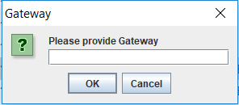

This is the first window, it will ask the gateway of the connected. This is important as Nmap will scan this gateway for all connected systems on it.
After entering gateway. It will open next window where it will check the connection and authenticity of the gateway
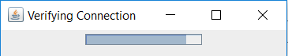

Something like this.
When connection is verified successfully, it will proceed to the next phase and open up a window like this.

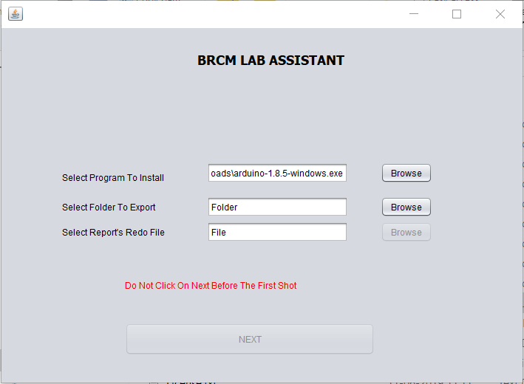
This will allow the user to select the program which is supposed to be installed in 1st box
Clicking on Browse next to the first box will open a file browser to select the program to be installed
as soon as the program is selected a window of regshot is opened

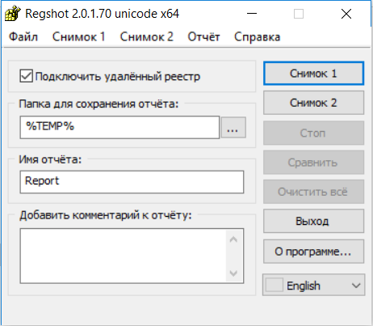

Here clicking on CHNMOK 1 button will create a snapshot of registry at this current point
after successful snapshot creation you can procede to install software as normally,
*Note : Don’t close the regshot window during the software installation
Once the software is installed go back to the regshot program and click on CHNMOK 2 button
it will create next registry snapshot at current point and enable all the remaing three disabled buttons
Clicking on CTON button will start the comparing process
and generate a Report in C:/ drive
This software can be closed now
NOW
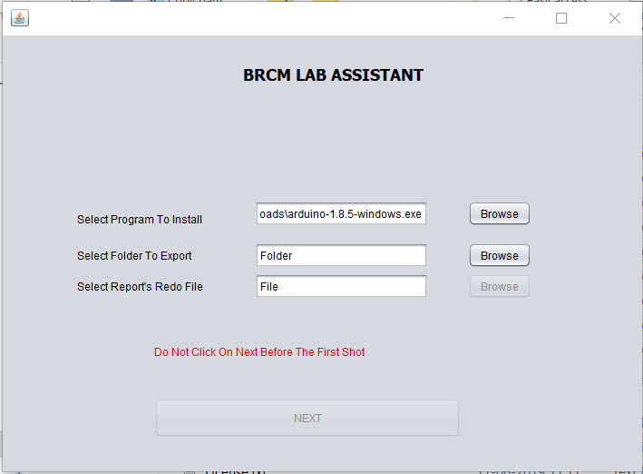

The 2nd browse button will be enabled and here the program folder of the software is to be selected
it can be found in the location where it is installed and usually in C:/program Files/<software Name>
This will enable the next browse button and here
the Report file which is created by regshot is supposed to be selected. Its found in C:/ but location further depend on where you selected during regshot comparing step
Once all 3 are selected, the Next button will be enabled
Meanwhile when we were installing our software Nmap is working in background to scan all possible available computers on the provided gateway
Clicking on Next Button will open up a window like this
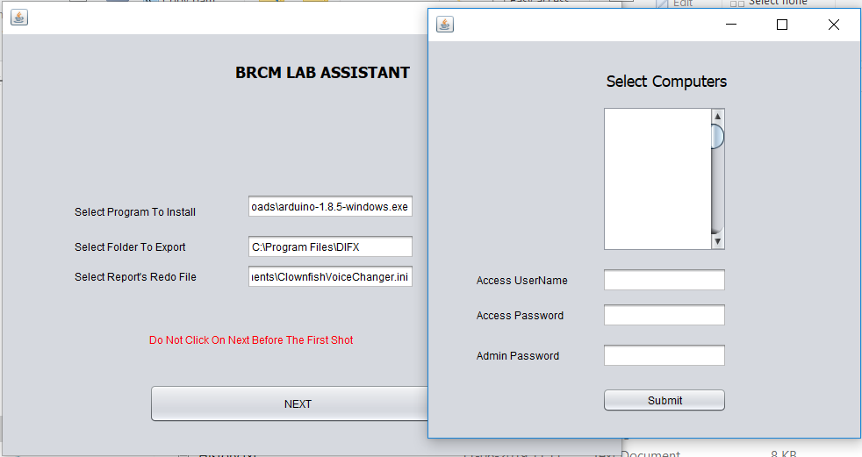
* Note : The list is empty here because my system was not the only system online on that gateway at that time

Now The first large box (A list box) will have a list of ip addresses of all the computers on the network at that moment.
We are supposed to select the ip addressed where we want our software to install
multiselection is allowed
Access UserName : It will ask the telnet username of all the system where software is supposed to install
Access Password : It will ask the telnet Password of all the system where software is supposed to install
Admin Password : Here the admin password of server system is supposed to be filled for reverse Ftp connection
Clicking on Submit button will begin the process of installation of software on all the selected systems
it will take some time depending on the size of the software

Back End:

2.5 Constraints :
The Admin access the Lab Assiatant System from one computer that All required dependencies installed and is connected to all the computers on which software should be installed

USE CASE DIAGRAM

ADMINISTRATOR:

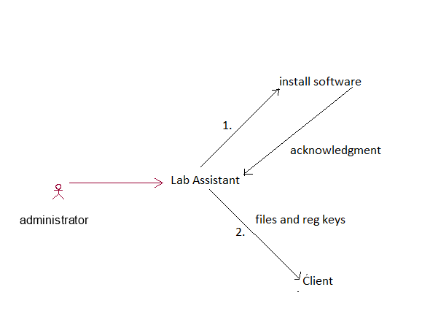

2.11 Assumptions and Dependencies :
- The user should have sufficient knowledge about computers.
- The computers should be on LAN
- The users know the English language, as the interface will be provided in English.

3.0 Specific Requirements:

3.1 Use case Reports:

USECASE | DESCRIPTION
Gateway | All Computers should have same gateway
Login | All Computers should have same telnet login id’s
Password | All Computers should have same telnet password
FTP Server | It should be active on server computer.
Admin Access | Lab Assistant should have Admin Access for registry edit.

3.2 Supplementary Requirements:
All other supplementary Requirements can be found on my github profile here
https://github.com/kanhaji/LabAssistant

